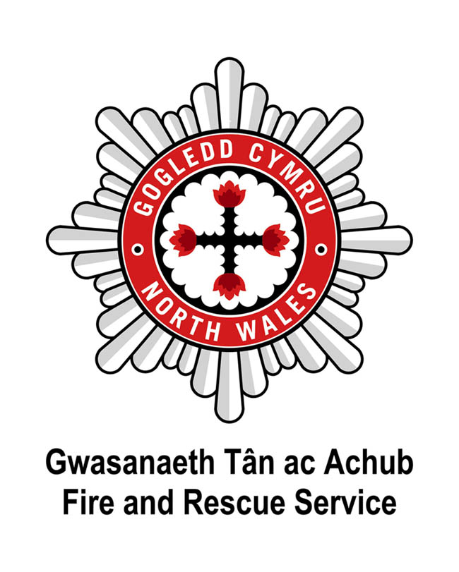

Dear Applicant

North Wales Fire and Rescue Service is an employer that is committed to equality of opportunity and welcomes applications from all sectors of the community who share our Core Values. North Wales Fire and Rescue Service have also signed the Armed Forces Covenant, which is a promise by the nation to ensure that those who serve or who have served in the armed forces, and their families, are treated fairly.

Please find enclosed the following:

- North Wales Fire and Rescue Service’s Core Values
- North Wales Fire and Rescue Service’s Welsh Language Scheme
- Guidance on completing your Application Form
- Application Form
- Equal Opportunities Monitoring Form

Should you require further information please do not hesitate to contact the Recruitment Team on 01745 535281 or email recruitment@northwalesfire.gov.wales.

Please be advised that the Service is unable to issue correspondence in acknowledgment of applications, however, all applicants will be advised whether or not they have been selected for interview.

Please return completed Application Forms via email to recruitment@northwalesfire.gov.wales. Applications received after the closing date will not be considered.

Please do not submit your CV with your Application Form, as only the information provided within the Application Form will be used at the interview shortlisting stage.

Applicants should be aware that social networking websites are a public forum, particularly if the applicant is part of a "network". Applicants should not assume that their entries on any website will remain private. Any messages, posts or pictures found that are deemed abusive, defamatory or in conflict with our Core Values will result in applications being withdrawn from the recruitment process.

Thank you for the interest you have shown in joining North Wales Fire and Rescue Service.

Yours sincerely

The Recruitment Team
North Wales Fire and Rescue Service

Welsh Language Scheme
At North Wales Fire and Rescue Service, we pride ourselves on having taken the issue of the Welsh language seriously over many years. By acknowledging our moral and legal duties to protect the cultural heritage of the area and to meet the expectations of the local community, we also acknowledge the positive service benefits of conducting our public business in both languages. Saving lives and reducing risk are at the heart of our mission - the language issue is vital to its success.
In accordance with statutory requirements, North Wales Fire and Rescue Service developed a Linguistic Skills Strategy to provide a means of responding appropriately to the Service's commitments contained in the Welsh Language Scheme.
As part of this Strategy, North Wales Fire and Rescue Service introduced the requirement for all new members of staff to have the ability to show basic Welsh language courtesy skills to at least Level 2. All new staff are allowed a specified period of time after formal appointment to achieve Level 2 standard.
Please note that Level 2 is the minimum requirement and that the assigned Welsh Language level for each post is listed in the Person Specification.
The Level 2 Assessment involves a short verbal test with an assessor – further help and support is available on the Welsh language pages of the North Wales Fire and Rescue Service website, where differing levels of Welsh language self-learning materials are available. This includes a number of soundbites and a practice booklet which can be used prior to the assessment. We are committed to supporting individuals as far as we can to attain the required level.
Applicants who already possess Welsh language skills or who are applying for posts with a Welsh Language requirement higher than Level 2 will be assessed against higher levels.
The demonstration of linguistic skills is also considered in the process of seeking promotion within North Wales Fire and Rescue Service.
For further information, please visit our website:
www.nwales-fireservice.org.uk/equality,-diversity-and-welsh-language-policy/welsh-language-policy.aspx?lang=en
North Wales Fire and Rescue Service welcomes communication in Welsh and English equally, and will respond without delay to correspondence or calls in both languages.
Please note which language you would prefer to receive communication in from North Wales Fire and Rescue Service: Welsh English Bilingual
Should you be shortlisted for interview, in which language would you prefer the interview to be conducted? Welsh English
If you would like to change your preference at any point please email:
recruitment@northwalesfire.gov.wales.

Guidance on completing your Application Form
- Please complete all sections of the Application Form in as much detail as possible, if a section does not apply to you, please write N/A (not applicable) in the space provided.

- Use a minimum font size of 11.

- If driving is a requirement of the post (as noted in the Person Specification), you will be required to provide a unique licence check code if you are shortlisted for interview. Visit https://www.gov.uk/view-driving-licence for more information on this.

- Only applicants who meet all of the Essential Criteria (as noted in the Person Specification) will be shortlisted for interview, Desirable Criteria may be referred to in the event there are significant applicants for a vacancy. Statements of fact and or inferences can not be accepted as evidence at the shortlisting stage, therefore, please provide clear examples of relevant evidence, for example;
Essential Criteria: Knowledge and understanding of Microsoft Office Applications.
Acceptable: In my current role I am required to produce reports for the organisation on monthly expenditure. I utilise Microsoft Access to provide statistical information with the necessary formulae to calculate the subtotals and totals for each month and year end. I then present the information in a report to the Board using Microsoft Word using both text and graphs to display the numerical information.
Not Acceptable: I have knowledge and understanding of Microsoft Office applications.
- Ensure your application details why you are interested in the role and what skills and experience you can bring to the role. Skills and experience gained through employment, voluntary work or social and domestic situations are all valid. CVs attached to Application Forms will not be read or considered at the shortlisting stage.

- In line with the Service’s Core Values and in compliance with the Rehabilitation of
Offenders Act 1974 and the Safeguarding Vulnerable Groups Act 2006, the Service does not require you to disclose details of any ‘spent’ convictions, unless however, the post you are applying for involves working with vulnerable adults or children – then you must disclose all convictions, cautions, reprimands or final warnings.
All posts involving regular contact with vulnerable groups will be subject to an Enhanced Criminal Records Disclosure (unspent and spent convictions disclosed) and all other posts will require a Basic level Criminal Records Disclosure (only unspent convictions disclosed).
The Person Specification advises whether an Enhanced or Basic level Criminal Records Disclosure is required for the particular post.
To confirm if a conviction is ‘spent’ or ‘unspent’ visit www.disclosurecalculator.org.uk.
- Ensure your Application Form is returned by noon of the closing date – late applications cannot be considered.

APPLICATION FORM – STRICTLY CONFIDENTIAL Please complete in black ink or type:
Application for the post of: ICT Digital Transformation Officer | Closing Date: noon, 12/06/2023
Surname: | Forenames(s):
Address:
Post Code: | Tel Home No:
Mobile No: | Tel No Work:
National Insurance No: | Email Address:
Do you hold a current UK driving licence? Yes No | What type of licence?
If you are successfully shortlisted for interview, and driving is a requirement of the post as indicated on the Person Specification, you will be required to provide a unique licence check code - failure to do so may result in your application failing to progress.
Are there any restrictions on your right to work in the UK? Yes No
If yes, please state restrictions and the expiry date of any permissions?

CURRENT / MOST RECENT POST
Name & Address of Employer | Position Held | Salary/Grade | Date Started | Period of Notice | Reason for Leaving
Please give brief details of your present duties/responsibilities:

PREVIOUS EMPLOYMENT (Please include any periods of unemployment)
Name & Address of Employer | Position Held | Salary | Date Started | Date To | Reason for Leaving
If you have ever been employed by North Wales Fire and Rescue Service please add your Fire Service Number here :

EDUCATIONAL AND OTHER QUALIFICATIONS (Schools/Colleges/University etc)

Name of School, College, University or Education / Training Centre | Subjects | Qualification/Examination Result | Awarding Body

CURRENT MEMBERSHIP OF PROFESSIONAL INSTITUTES / BODIES

Name of Institute | Grade / Level of Membership
EXPERIENCES/ACHIEVEMENTS

Please give details of your knowledge, skills and experience which you feel are relevant to the requirements of this post and your application. (Please attach a continuation sheet if required). It is essential that the application demonstrates that you are able to satisfy the essential requirements of the post, as detailed in the person specification - failure to do so may result in your application failing to progress.

REHABILITATION OF OFFENDERS ACT 1974 and SAFEGUARDING VULNERABLE GROUPS ACT 2006

Under the provisions of these Acts and Regulations you need not normally disclose details of any ‘spent’ convictions. However, if the post you are applying for involves regulated activity with vulnerable adults or children then you must disclose all convictions, cautions, reprimands or final warnings, as if your application is successful you will be subject to an Enhanced DBS Check. All other posts will require a Basic Level DBS Check. By signing this application form you are hereby giving consent to undertake the above checks if your application is successful. The Person Specification will advise if the post you are applying to requires an Enhanced or Basic Level DBS Check.
Do you have any ‘unspent’ convictions? | Yes No
(If Yes, please give details of the offence date and the sanction imposed)

Please only answer the following question if the post you are applying to will be subject to an Enhanced DBS Check. Do you have any ‘spent’ convictions, cautions, reprimands or final warnings? | Yes No
(If Yes, please give details of the offence date and the sanction imposed)

KNOWLEDGE OF LANGUAGES – Please tick where appropriate

Are you able to speak Welsh to the standard outlined within the person specification?  Are you able to speak English to the standard outlined within the person specification? | Yes No  Yes No
Are you able to read/write in Welsh to the standard outlined within the person specification?  Are you able to read/write in English to the standard outlined within the person specification? | Yes No  Yes No
Should you be shortlisted for interview, in which language would you prefer the interview to be conducted? | Welsh English
In which language would you prefer to receive communication from North Wales Fire and Rescue Service? | Welsh English Bilingual

ADDITIONAL INFORMATION

Are you personally connected to any employee of North Wales Fire & Rescue Service (examples of a personal connection include, but are not limited to, relatives, partners or friends and people you communicate with outside of employment either face to face, over the phone, or online). If so, please provide details below – please attach another sheet if required.
Name:
In what capacity are they known to you:
Have you discussed this application with them? Yes No

A guaranteed interview will be offered to Veterans and the Spouses/Partners of Veterans and Regular serving members of the Armed Forces. This is conditional on the essential criteria of the job being met and no longer than 5 years has lapsed since leaving the Armed Forces (subject to supporting information being provided on request).
Are you or your spouse a current member of the UK Armed Forces? Yes No
If yes, please provide details:
Have you previously been a member of the UK Armed Forces? Yes No
If yes, please provide details:

Please give any dates in the near future when you will not be available for interview.

REFERENCES

Please give the name and address of two referees, one of which should be your current employer (note we will not contact current employers unless you have been offered a position with North Wales Fire & Rescue Service.) I hereby authorise you to take up references from my previous employer(s), my present employer (once the offer of employment has been confirmed in writing) and any personal referees. In addition, I hereby authorise you to take up other reference checks as you may deem appropriate.

Name & Address (including email) | How long and in what capacity has the referee known you
Have you recently received an exit  payment from another public body? | Yes |  | Date payment received:
 | No
Are you in receipt of a pension payment from any other public sector organisation? | Yes |  | If yes, please provide details:
 | No

DECLARATION

Canvassing by an applicant of members of the Fire & Rescue Authority either directly or indirectly shall disqualify the candidate concerned for the appointment.
I declare that the statements given on this form are true and accurate to the best of my knowledge and belief and I am not aware of any circumstances, which if known, or become known, to the Fire & Rescue Authority might cause them to question my suitability for appointment.

Signed:  Forms received via email will not require a wet signature. | Date:

Where did you see the advertisement?

Thank you for taking the time to complete this application.

Please return completed Application Forms via email to: recruitment@northwalesfire.gov.wales.

Please do not submit your CV with your Application Form, as only the information provided within the Application Form will be used at the shortlisting stage.
Applications received after the closing date will not be considered.

FOR THE ATTENTION OF HR: to be detached from Application form upon receipt

EQUALITIES MONITORING
Name: |  |  | Date of Birth:
Date completed:
Post Applied For:
Fire Service Number: (Internal Application only)
As a public authority North Wales Fire and Rescue Service is required to take steps and aims to promote equality of opportunity and combat discrimination. This information does not form any part of your application and is removed from your application form before submission to the short-listing stage. The information gathered will be used for monitoring, and informing positive action initiatives.

Ethnicity: What is your ethnic group?
White |  |  |  | Mixed/multiple ethnic groups
 | British |  |  |  | White and Black Caribbean
 | Welsh |  |  |  | White and Black African
 | English |  |  |  | White and Asian
 | Scottish |  |  |  | Do not wish to state
 | Irish/Northern Irish |  |  |  | Other please specify below:
 | Gypsy or Irish Traveller
 | Do not wish to state
 | Other please specify below: |  |  | Asian/Asian British
 |  |  |  |  | Indian
 |  |  |  |  | Pakistani
Black/African/Caribbean/Black British |  |  |  |  | Bangladeshi
 | African |  |  |  | Chinese
 | Caribbean |  |  |  | Do not wish to state
 | Do not wish to state |  |  |  | Other please specify below:
 | Other please specify below:
Any other Ethnic Group
 | Other please specify below:

Sex and Sexual Identity:
Sex: What is your sex? |  |  | Sexual Identity: which best describes how you think of yourself?
 | Female |  |  | Heterosexual/Straight
 | Male |  |  | Gay/Lesbian
 |  |  |  | Bisexual
Transgender: Is your gender different from birth? |  |  |  | Do not wish to state
 | Yes |  |  | Other please specify below:
 | No
 | Do not wish to state

Disability and Marriage or Civil Partnership
Disability
North Wales Fire and Rescue Service operate an Interview Guarantee Scheme for candidates with disabilities (Two Ticks). This means that any job applicant, who has a disability and meeting the essential job requirement set out in the person specification, will be invited to the selection process/interview. A disability is defined under the Equality Act 2010 as a physical or mental impairment, which has a substantial long-term adverse impact on a person’s ability to carry out normal day-to-day activities.
Marriage or Civil Partnership Same Sex Couples
Civil partnerships in the United Kingdom, granted under the Civil Partnership Act 2004, allow same-sex couples to obtain essentially the same rights and responsibilities as civil marriage.

The Marriage (Same Sex Couples) Act 2013 legalised full same-sex marriage starting from March 2014, although civil partnership also remains available.

Disability |  |  | Marriage or Civil Partnership
Do you have a long-standing physical or mental health condition or disability?  By long standing, we mean anything that has lasted or is likely to last at least 12 months. |  |  | What is your legal marital or same-sex status? | Opposite Sex | Same Sex
 | Physical Impairment |  | Married
 | Sensory Impairment |  | Living with a partner
 | Mental Health condition |  | Registered Civil Partnership
 | Long standing illness or health condition
 |  |  | Single
 | Other such as disfigurement |  | Widowed
 | Learning Disability |  | Separated
 | Do not wish to state |  | Divorced
 | None |  | Do not wish to state

National Identity and Religion
National Identity: |  |  |  | Religion: What is your religion?
 | British |  |  |  |  | No Religion
 | Welsh |  |  |  |  | Christian (All denominations)
 | Scottish |  |  |  |  | Buddhist
 | English |  |  |  |  | Hindu
 | Irish/Northern Irish |  |  |  |  | Jewish
 | Do not wish to state |  |  |  |  | Sikh
 | Other please specify below: |  |  |  |  | Muslim
 |  |  |  |  |  | Do not wish to state
 |  |  |  |  |  | Other please specify below:

Welsh language status:
Fluent | Learning | Attending Lessons | Cannot speak Welsh at all

OFFICIAL HR USE ONLY:
Date entered on HRIS

