**NORTH WALES**

**FIRE AND RESCUE SERVICE**



**Performance Monitoring Report**

**For the first quarter**

**April – June 2023**

**Figures are provisional and may be subject to minor amendment.**

**Contents**

1 All Incidents 2

Actions taken to improve performance during the previous quarter 3

2 Fires, by Category and Motive 4

Actions taken to support the reduction of fire events during the previous quarter 5

3 Primary Fires, by Property Type and Motive 6

4 Accidental Fires in Dwellings 7

Action taken to further understand our community demographic and risk during the previous quarter 8

5 Fatalities and Casualties from Accidental Fires in Dwellings 9

6 Smoke Detectors – Accidental Dwelling Fires (ADFs) 10

Actions taken to support communities by increasing smoke alarm ownership and safety education during the previous quarter 11

7 False Alarms 12

Actions taken to reduce Hospital AFAs duirng the previous quarter 13

8 Special Service Calls 14

Actions taken to reduce Special Service Calls duirng the previous quarter 15

9 Road Traffic Collisions and Extrications/Release 16

Actions taken to reduce RTCs during the previous quarter 17

10 Monitoring against Improvement and Well-being Objective 1 18

10.1 Safe and Well Checks 18

Actions taken to improve Safe and Well Check performance duirng the previous quarter 19

11 Planned 18 Pump Availability 20

12 Staff Absences 21

Glossary 22

# All Incidents

1. During the first quarter of the 2023/24 financial year, the Service attended 1,635 emergency incidents and false alarms, a 3.8% increase on the same period in the previous financial year (1,575).

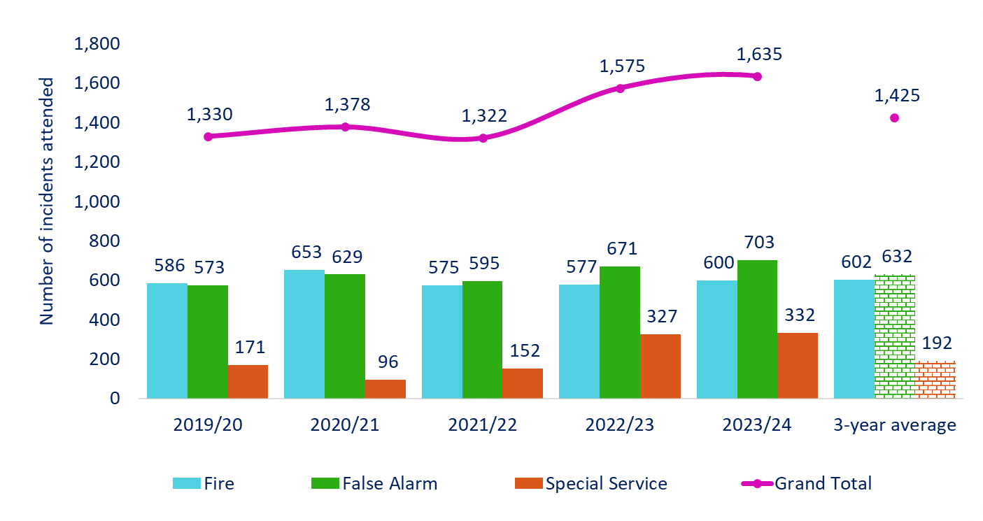

|  |  |  |  |  |  |  |  |  |  |  |
| --- | --- | --- | --- | --- | --- | --- | --- | --- | --- | --- |
| **Category** | **Year** | **Q1** | **Q2** | **Q3** | **Q4** | **Year- to-Date**  **(YTD)** | **% change YTD** |  | **Average of 3 previous years** | **% change YTD / Average of 3 previous years** |
|  | | | | | | | |  |  | |
| Total incidents attended | **2023-24** | **1,635** |  |  |  | **1,635** | ⬆  3.8% |  | 1,425 | ⬆  14.7% |
| 2022-23 | 1,575 |  |  |  | 1,575 |  |
|  |  |  |  |  |  |  |  |  |  |  |
| Total fires | **2023-24** | **600** |  |  |  | **600** | ⬆  4.0% |  | 602 | 🡻  0.3% |
| 2022-23 | 577 |  |  |  | 577 |  |
|  |  |  |  |  |  |  |  |  |  |  |
| Total special service incidents | **2023-24** | **332** |  |  |  | **332** | ⬆  1.5% |  | 192 | ⬆  72.9% |
| 2022-23 | 327 |  |  |  | 327 |  |
|  | | | | | | | | | | |
| Total false alarms | **2023-24** | **703** |  |  |  | **703** | ⬆  4.8% |  | 632 | ⬆  11.2% |
| 2022-23 | 671 |  |  |  | 671 |  |
| *The final two columns show: the average of the three previous financial years (based on the equivalent reporting period); the percentage change based on the difference between the current financial year and the three year average. | | | | | | | | | | |

## Actions taken to improve performance during the previous quarter

* **AFAs** **Increase** – We are aware of the increase in AFAs in non-domestic settings. These calls are predominately from BCUHB (numerous activation reasons). We continue to work with BCUHB in reducing these AFA activations. Following the retirement of fire service staff within the Protection department, the link between West and East Area is now being re-established. A new working strategy is being developed to reduce AFAs.
  + The increase in domestic (dwelling) attendance to AFAs is due to the increased number of vulnerable and aged people using monitored systems.
* **SSCs Increase** –The overall increase in SSCs is due to a change in organisational policy in relation to attending SSCs, making crew more visible in the community.
  + Figure appears to have stabilised and is comparable to Q1 last year.
  + FS team continues to deliver RTC interventions to colleges across the service area. Olivia’s Story has been delivered to over 2,406 students in colleges, and work place apprentices in organisations such as Airbus UK.

# Fires, by Category and Motive

* 1. A total of 600 fires were attended; a 4.0% increase from 577 in 2022/23.
  2. **Primary fires –** There was a 2.2% increase in primary fires from 226 to 231 compared with the same period in the previous financial year, which was 1.3% below the 3‑year average of 234.
  3. **Secondary fires –** There was a 7.2% increase in secondary fires, from 332 to 356, which was 4.7% above the 3-year average of 340.
  4. **Chimney fires –** The number of chimney fires decreased to 13 from 19 during the same period in the previous financial year, which was 53.6% below the 3‑year average of 28.

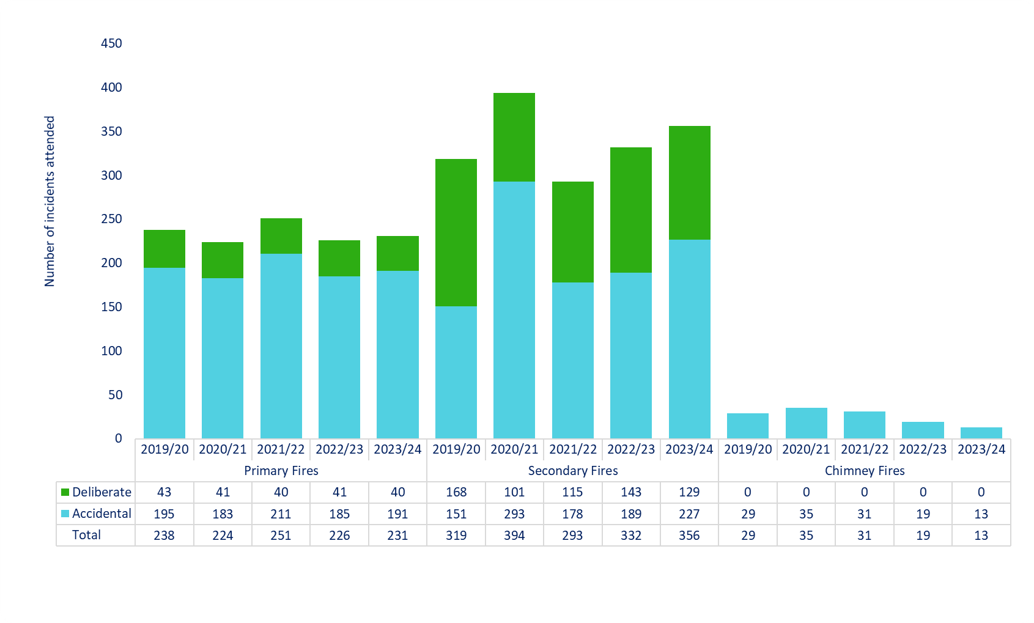

|  |  |  |  |  |  |  |  |  |  |  |  |
| --- | --- | --- | --- | --- | --- | --- | --- | --- | --- | --- | --- |
| **Category** | **Year** | **Q1** | **Q2** | **Q3** | **Q4** | **Year- to-Date**  **(YTD)** | **% change YTD** |  | **Average of 3 previous years** | **% change YTD / Average of 3 previous years** | |
|  |  |  |  |  |  |  |  |  |  | |  |
| Primary fires | **2023-24** | **231** |  |  |  | **231** | 🡹  2.2% |  | 234 | | ⬇  1.3% |
| 2022-23 | 226 |  |  |  | 226 |  |
|  |  |  |  |  |  |  |  |  |  | |  |
| Secondary fires | **2023-24** | **356** |  |  |  | **356** | ⬆  7.2% |  | 340 | | ⬆  4.7% |
| 2022-23 | 332 |  |  |  | 332 |  |
|  |  |  |  |  |  |  |  |  |  | |  |
| Chimney fires | **2023-24** | **13** |  |  |  | **13** | 🡻  31.6% |  | 28 | | ⬇  53.6% |
| 2022-23 | 19 |  |  |  | 19 |  |
| *The final two columns show: the average of the three previous financial years (based on the equivalent reporting period); the percentage change based on the difference between the current financial year and the three year average. | | | | | | | | | | | |

## Actions taken to support the reduction of fire events during the previous quarter

There was a very small increase of 6 primary accidental incidents attended which remains below the 3-year average figure.

A very hot and dry spell during the early part of Q1 can account for the rise in secondary accidental fires.

* 4,439 SAWCs have been delivered across North Wales in line with our current strategy target;
* Partnership Managers continue to foster relationships with external agencies to encourage high quality referrals.
* Work with strategic partners has continued, identifying potential risks to reduce deliberate fire incidents;
* Deliberate fire setting intervention schemes continue to be facilitated in-house and by DangerPoint; 3 internally delivered by the Arson Reduction Team, and 12 Firesafe delivered by DangerPoint.
* New Wales Wildfire Board has been established and the All Wales Wildfire Charter drafted to support the reduction in accidental and deliberate secondary fires;
* Campaign Steering Group (CSG) continued to work with Corporate Communications to proactively promote safety and wildfire messaging across all media platforms; for example, dementia group walks, attendance at Pride events, engagement with hard of hearing groups and societies as well as the production of new video, hospital visits and engagement at carer group meetings, and refreshing of home safety advice and guidance to minority groups on our internet pages.

# Primary Fires, by Property Type and Motive

1. 1. During the first quarter of 2023/24, 40 primary fires were started deliberately, compared with 41 during 2022/23.
   2. There were 8 deliberate fires at HMP Berwyn, compared with 4 in the same quarter of the previous financial year.

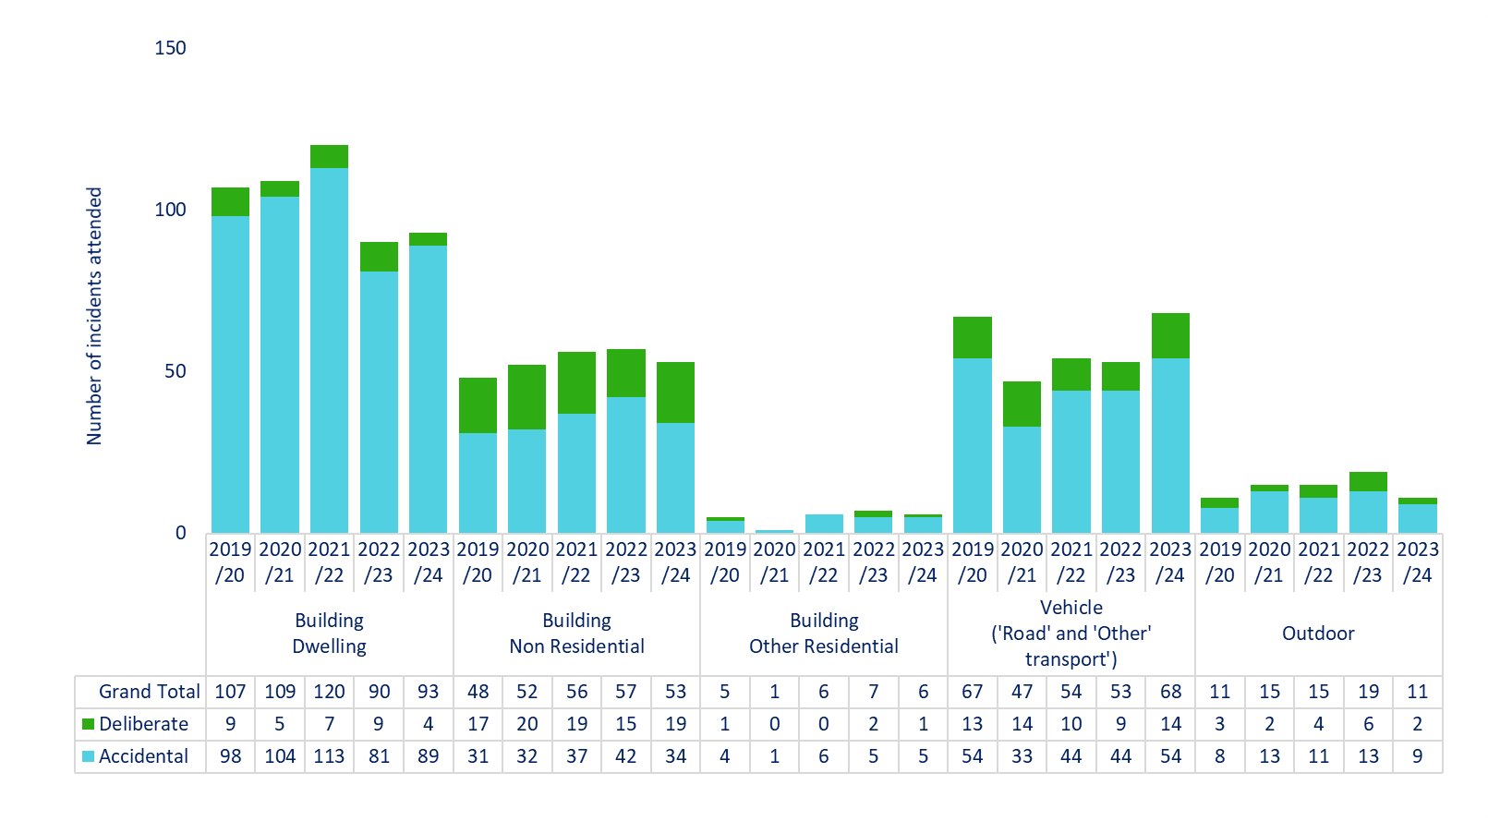

|  |  |  |  |  |  |  |  |  |  |  |
| --- | --- | --- | --- | --- | --- | --- | --- | --- | --- | --- |
| **Category** | **Year** | **Q1** | **Q2** | **Q3** | **Q4** | **Year- to-Date**  **(YTD)** | **% change YTD** |  | **Average of 3 previous years** | **% change YTD / Average of 3 previous years** |
|  | | | | | | | |  |  | |
| All deliberate primary fires | **2023-24** | **40** |  |  |  | **40** | 🡻  2.4% |  | 41 | ⬇  2.4% |
| 2022-23 | 41 |  |  |  | 41 |  |
|  |  |  |  |  |  |  |  |  |  |  |
| All accidental primary fires | **2023-24** | **191** |  |  |  | **191** | 🡹  3.2% |  | 193 | 🡻  1.0% |
| 2022-23 | 185 |  |  |  | 185 |  |
| *The final two columns show: the average of the three previous financial years (based on the equivalent reporting period); the percentage change based on the difference between the current financial year and the three year average. | | | | | | | | | | |

# Accidental Fires in Dwellings

1. The Service attended 89 accidental dwelling fires during the reporting period; 8 (9.9%) more than during the same period of the previous financial year (81). However, this is still 10.1% below the 3-year average of 99.

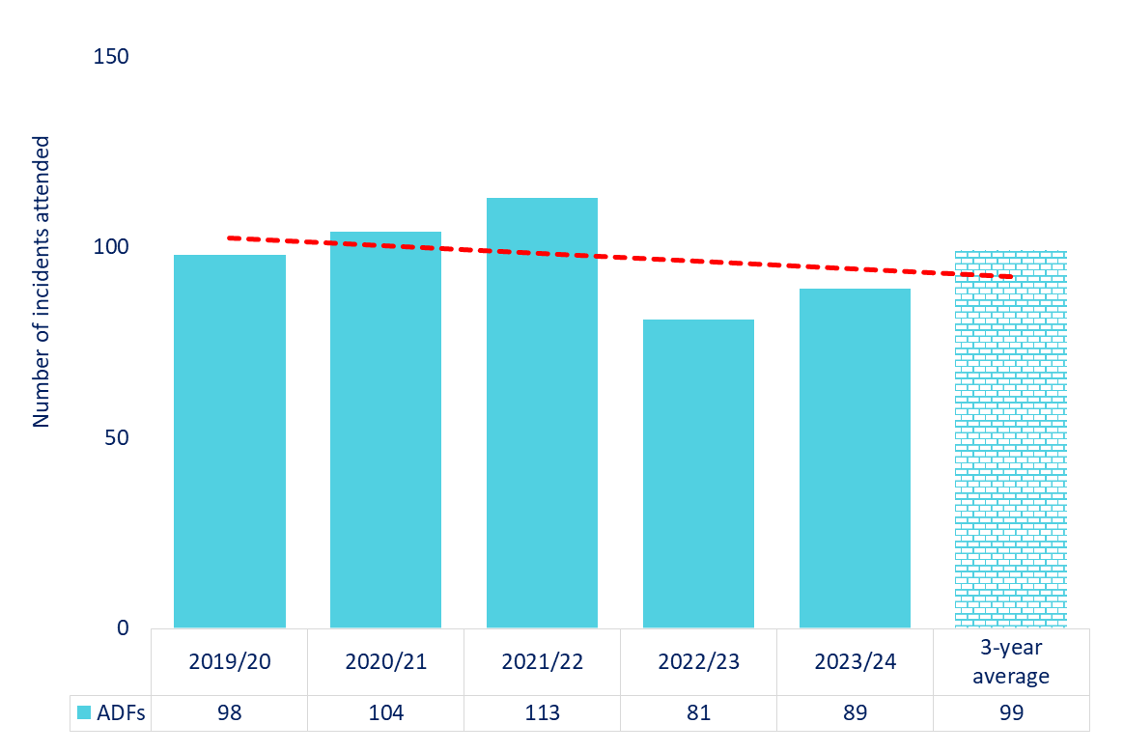

|  |  |  |  |  |  |  |  |  |  |  |
| --- | --- | --- | --- | --- | --- | --- | --- | --- | --- | --- |
| **Category** | **Year** | **Q1** | **Q2** | **Q3** | **Q4** | **Year- to-Date**  **(YTD)** | **% change YTD** |  | **Average of 3 previous years** | **% change YTD / Average of 3 previous years** |
|  | | | | | | | |  |  | |
| Accidental fires in dwellings | **2023-24** | **89** |  |  |  | **89** | 🡹  9.9% |  | 99 | ⬇  10.1% |
| 2022-23 | 81 |  |  |  | 81 |  |
| *The final two columns show: the average of the three previous financial years (based on the equivalent reporting period); the percentage change based on the difference between the current financial year and the three year average. | | | | | | | | | | |

## Action taken to further understand our community demographic and risk during the previous quarter

* During Q1, a total of 4,439 SAWCs were completed of which 1,353 (30.5%) were high priority. 783 (57.9%) of these came from a partner agency.
* The WT/DC ops crews SAWC target increased to 15 each tour from Q1.
* Partnership Managers continue to explore new relationships with external partners to identify those persons most vulnerable to fire and provide them with suitable advice and interventions.
* Ongoing work with regional hoarding groups to identify people at risk continued.
* Local and national (Wales & NFCC) campaigns have been supported in line with our own Campaign Steering Group (CSG) calendar. For example, dementia group walks, attendance at Pride events, engagement with hard of hearing groups and societies, as well as the production of a new video, hospital visits and engagement at carer group meetings, and the refreshing of home safety advice and guidance to minority groups on our internet pages has all taken place. All campaigns are listed in the campaign calendar.
* Locally run and targeted outreach days have continued to be supported by external agencies. Areas are leafleted by Prevention teams who then return to provide SAWCs (Crews and HSSWs).
* Proactive hot spotting campaigns following significant incidents produced SAWC referrals and community reassurance following incidents.
* The partnership between NWFRS and Cartrefi Conwy and Care & Repair continued to identify high priority referrals – we engage with vulnerable people who are discharged from hospital/care settings to provide interventions where required.
* Educationalists continued to promote smoke alarm ownership and testing as part of their delivery across North Wales schools. 55 visits took place, resulting in 5,824 children and young people being educated. This included 22 crucial crew visits.
* Continued with the re-engagement programme by contacting occupiers who have previously had SAWCs and who were classified as high priority.
* Partnership Managers continued to attend vulnerable adult and safeguarding multi-agency meetings on a regular basis to help identify persons vulnerable to fire. Representatives from the ART department attend various strategy meetings, a Child Protection Case Conference, along with the Safeguarding lead who attends the Domestic Homicide reviews and North Wales Adult/Children’s Safeguarding Board.

# Fatalities and Casualties from Accidental Fires in Dwellings

1. There were no ADF fatalities during the first quarter of the 2023/24 financial year, which aligns with the same period last year. There were 2 serious, and 10 slight injuries, compared with 0 and 2 respectively. The number of precautionary checks increased from 2 to 6, and the number of people requiring first aid at the scene also increased from 6 to 10.

|  |  |  |  |  |  |
| --- | --- | --- | --- | --- | --- |
| **Severity of Injury** | **2019/20** | **2020/21** | **2021/22** | **2022/23** | **2023/24** |
| Precautionary Check | 7 | 11 | 17 | 2 | 6 |
| First Aid | 13 | 6 | 10 | 6 | 10 |
| Injuries - Slight | 10 | 9 | 15 | 2 | 10 |
| Injuries - Serious | 2 | 0 | 1 | 0 | 2 |
| Fatality | 1 | 3 | 3 | 0 | 0 |
| Total | 33 | 29 | 46 | 10 | 28 |

|  |  |  |  |  |  |  |  |  |  |  |
| --- | --- | --- | --- | --- | --- | --- | --- | --- | --- | --- |
| **Category** | **Year** | **Q1** | **Q2** | **Q3** | **Q4** | **Year- to-Date**  **(YTD)** | **%**  **change YTD** |  | **Average of 3 previous years** | **Change YTD / Average of 3 previous years** |
|  | | | | | | | |  |  | |
| Injuries from accidental fires in dwellings | **2023-24** | **28** |  |  |  | **28** | 🡹  180.0% |  | 26 | 🡹  7.7% |
| 2022-23 | 10 |  |  |  | 10 |  |
|  |  |  |  |  |  |  |  |  |  |  |
| Deaths from accidental fires in dwellings | **2023-24** | **0** |  |  |  | **0** | 🡺  0% |  |  |  |
| 2022-23 | 0 |  |  |  | 0 |  |

# Smoke Detectors – Accidental Dwelling Fires (ADFs)

1. Smoke/heat detectors were present at the majority of ADFs, although not all went on to operate. At 9 of the ADFs, no detector was fitted. 
   1. Of the 89 ADFs, 82 were confined to the room of origin, the item first ignited, or there was heat/smoke damage only.

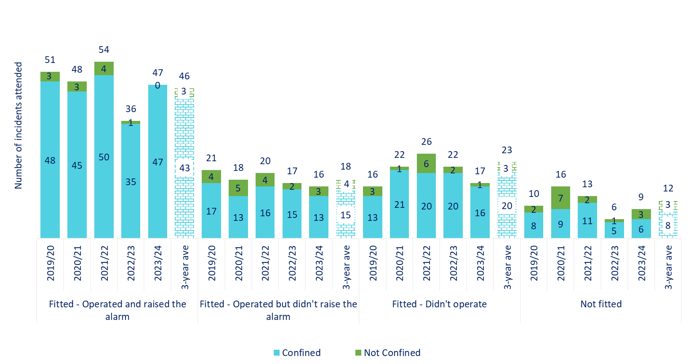

|  |  |  |  |  |  |  |  |  |  |  |
| --- | --- | --- | --- | --- | --- | --- | --- | --- | --- | --- |
| **Category** | **Year** | **Q1** | **Q2** | **Q3** | **Q4** | **Year- to-Date**  **(YTD)** | **% change YTD** |  | **Average of 3 previous years** | **% change YTD / Average of 3 previous years** |
|  | | | | | | | |  |  | |
| Smoke detector fitted which operated and raised alarm | **2023-24** | **47** |  |  |  | **47** | 🡹  30.6% |  | 46 | 🡹  2.2% |
| 2022-23 | 36 |  |  |  | 36 |  |
|  |  |  |  |  |  |  |  |  |  |  |
| Smoke detector fitted which operated but didn’t raise the alarm | **2023-24** | **16** |  |  |  | **16** | ⬇  5.9% |  | 18 | ⬇  11.1% |
| 2022-23 | 17 |  |  |  | 17 |  |
|  |  |  |  |  |  |  |  |  |  |  |
| Smoke detector didn’t operate | **2023-24** | **17** |  |  |  | **17** | 🡻  22.7% |  | 23 | 🡻  26.1% |
| 2022-23 | 22 |  |  |  | 22 |  |
|  |  |  |  |  |  |  |  |  |  |  |
| Smoke detector not fitted | **2023-24** | **9** |  |  |  | **9** | ⬇  50.0% |  | 12 | ⬇  25.0% |
| 2022-23 | 6 |  |  |  | 6 |  |
| *The final two columns show: the average of the three previous financial years (based on the equivalent reporting period); the percentage change based on the difference between the current financial year and the three year average. | | | | | | | | | | |

## Actions taken to support communities by increasing smoke alarm ownership and safety education during the previous quarter

* Continued to work with partners to identify the most vulnerable people in our communities and provide them with suitable advice and interventions.
* SAWC output by Crews and HSSW was monitored closely.
* Quality assurance of SAWCs was conducted by Partnership Managers.
* Education and awareness of the correct siting and fitting of smoke alarms in people’s homes to prevent unnecessary activations and false alarms also continued.
* NWFRS has continued to promote regular testing of smoke alarms using all media platforms.
* Endeavours continued to ensure our advice provided details and actions to be taken if a fire starts or a smoke alarm activates in the home.
* Educationalists continued to promote smoke alarm ownership and testing as part of the delivery across North Wales schools.

# False Alarms

* 1. In the reporting period, there were 703 false alarms; a 4.8% increase from 671 in the same quarter of the previous financial year. There was a 2.2% decrease in AFAs from 416 to 407. False alarms made with good intent increased from 241 to 282.

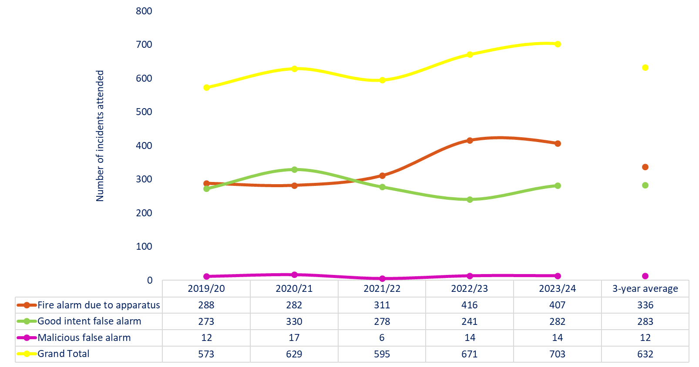

|  |  |  |  |  |  |  |  |  |  |  |  |  |  |  |  |  |  |
| --- | --- | --- | --- | --- | --- | --- | --- | --- | --- | --- | --- | --- | --- | --- | --- | --- | --- |
| **Category** | **Year** | **Q1** | **Q2** | | **Q3** | | **Q4** | | **Year- to-Date**  **(YTD)** | | **% change YTD** | |  | | **Average of 3 previous years** | | **% change YTD / Average of 3 previous years** |
|  |  | | | | | | | | | | | | | | |  |  |
| Total false alarm | **2023-24** | **703** |  | |  | |  | | **703** | | ⬆  4.8% | |  | | 632 | | ⬆  11.2% |
| 2022-23 | 671 |  | |  | |  | | 671 | |  | |
|  |  |  | |  | |  | |  | |  | |  | |  | |  |  |  |
| AFA | **2023-24** | **407** |  | |  | |  | | **407** | | 🡻  2.2% | |  | | 336 | | ⬆  21.1% |
| 2022-23 | 416 |  | |  | |  | | 416 | |  | |
|  |  |  | |  | |  | |  | |  | |  | |  | |  |  |  |
| False alarms made with good intent | **2023-24** | **282** |  | |  | |  | | **282** | | ⬆  17.0% | |  | | 283 | | 🡻  0.4% |
| 2022-23 | 241 |  | |  | |  | | 241 | |  | |
|  |  |  | |  | |  | |  | |  | |  | |  | |  |  |  |
| Malicious | **2023-24** | **14** |  | |  | |  | | **14** | | 🡺  0.0% | |  | | 12 | | ⬆  16.7% |
| 2022-23 | 14 |  | |  | |  | | 14 | |  | |
| *The final two columns show: the average of the three previous financial years (based on the equivalent reporting period); the percentage change based on the difference between the current financial year and the three year average. | | | | | | | | | | | | | | | | | |

## Actions taken to reduce Hospital AFAs duirng the previous quarter

* The Fire Safety department are re-establishing robust lines of contact with the major hospitals in North Wales to reduce AFAs.
  + To support this, the Fire Safety department have established formal meetings each Monday, Wednesday, and Friday to review all incidents that have occurred in the previous period. Each incident is reviewed to determine the cause of actuation as being either accidental, malicious, or as a result of a fault on the system. This enables Fire Safety to interact with all hospitals to inform and educate in the prevention of AFA actuation.
  + During Q1, 134 hospital AFA calls were received. This is the highest number of calls in the last five years. 62 were attended, 1.6% less than in the same period of the previous financial year (63). 72 calls were not attended, 71.4% more than in the same period of 2022/23 (42).

# Special Service Calls

1. Special service calls increased 1.5% to 332 during the reporting period, compared with 327 in same period of 2022/23. Road traffic collisions increased 45.3% from 53 to 77, whilst ‘other than RTC’ incidents decreased 6.9%, from 274 to 255. The rise in SSCs attended was expected following the Service’s decision to increase visability in the community.

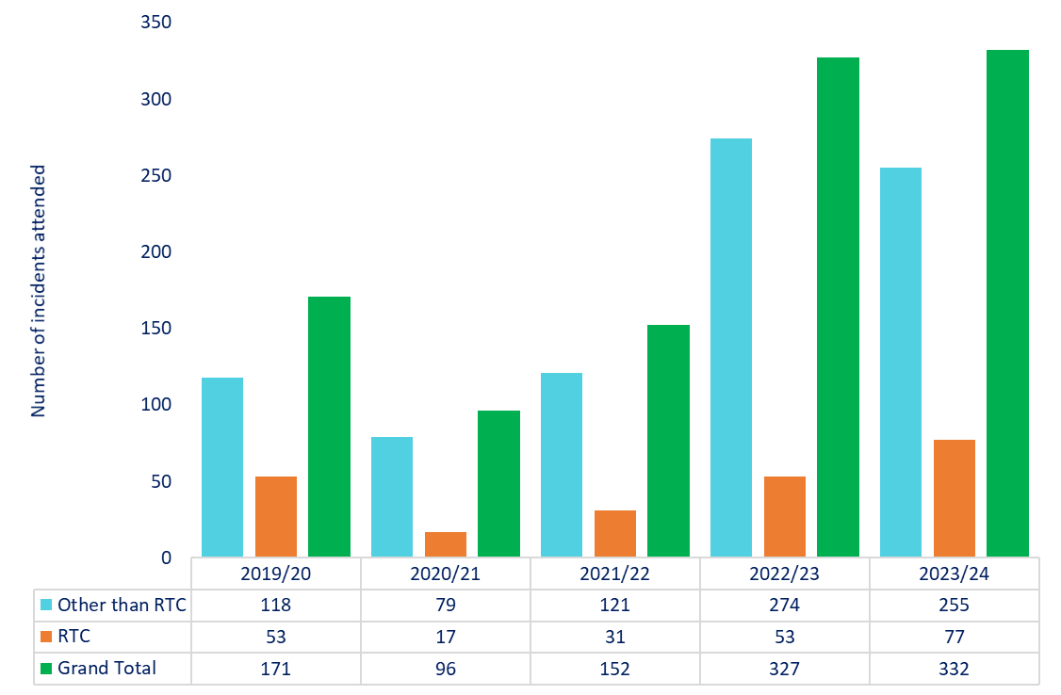

|  |  |  |  |  |  |  |  |  |  |  |
| --- | --- | --- | --- | --- | --- | --- | --- | --- | --- | --- |
| **Category** | **Year** | **Q1** | **Q2** | **Q3** | **Q4** | **Year- to-Date**  **(YTD)** | **% change YTD** |  | **Average of 3 previous years** | **% change YTD / Average of 3 previous years** |
|  | | | | | | | |  |  | |
| Total special service calls | **2023-24** | **332** |  |  |  | **332** | ⬆  1.5% |  | 192 | ⬆  72.9% |
| 2022-23 | 327 |  |  |  | 327 |  |
|  | | | | | | | | | | |
| Road traffic collisions (RTC) | **2023-24** | **77** |  |  |  | **77** | ⬆  45.3% |  | 34 | ⬆  126.5% |
| 2022-23 | 53 |  |  |  | 53 |  |
|  |  |  |  |  |  |  |  |  |  |  |
| Other than RTC | **2023-24** | **255** |  |  |  | **255** | 🡻  6.9% |  | 158 | ⬆  61.4% |
| 2022-23 | 274 |  |  |  | 274 |  |
| *The final two columns show: the average of the three previous financial years (based on the equivalent reporting period); the percentage change based on the difference between the current financial year and the three year average. | | | | | | | | | | |

## Actions taken to reduce Special Service Calls duirng the previous quarter

* The reason for NWFRS’s increased attendance to SSCs is a result of a conscious decision taken by the organisation to support an increased visibility in the community as we emerged from Covid-19 restrictions.
* FS team continue to deliver “Olivia’s Story” across the service area. 120 educational sessions have taken place resulting in 2,406 young people having received this intervention.
* Supported NWP at numerous road safety initiatives run at fire stations, delivering a presentation to those caught speeding within a controlled zone.
* Delivered our first, very well supported “Biker Down” course at Rhyl Fire Station. This course not only delivers raod safety advice, but also gives life saving advice and guidance to riders who are first on scene. 5 further events are planned this year. 21 attended the first session held in Rhyl, and 4 further sessions will take place in coming months, with the first 2 at maximum capacity.
* The Pheonix team contiued to include road safety as part of their course content. 6 courses were delivered in quarter one (55 children and young people).

# Road Traffic Collisions and Extrications/Release

* 1. Out of the 77 road traffic collisions attended in the first quarter of the 2023/24 financial year, 20 (26.0%) involved the Service using equipment to extricate at least one casualty from the vehicle. Whilst 40 incidents resulted in injuries, the majority of casualties sustained only slight injuries.

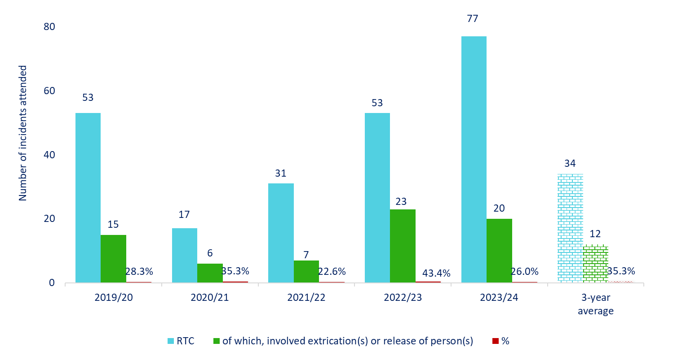

|  |  |  |  |  |
| --- | --- | --- | --- | --- |
| **77** | RTC incidents attended |  | **Severity of Injury \*** | **Number of people** |
| **40** | incidents where people sustained injury |  | Precautionary check | 4 |
| **20** | incidents involved extrication / release |  | First Aid | 16 |
|  |  |  | Injuries - Slight | 26 |
|  |  |  | Injuries - Serious | 19 |
|  |  |  | Fatalities | 4 |
|  |  |  | *\*RTC injuries - where available are recorded in the IRS in the same categorisation as fire injuries* | |

## Actions taken to reduce RTCs during the previous quarter

* NWFRS is a stakeholder and key participant of the North Wales Road Safety Group, supporting the delivery of interventions where required.

# Monitoring against Improvement and Well-being Objective 1

1.1*To support people to prevent accidental dwelling fires and stay safe if they do occur.*

## Safe and Well Checks

The Service completed 4,439 Safe and Well Checks during the first quarter of the 2023/24 financial year, of which 1,356 (30.5%) were undertaken in response to a referral from a partner agency.

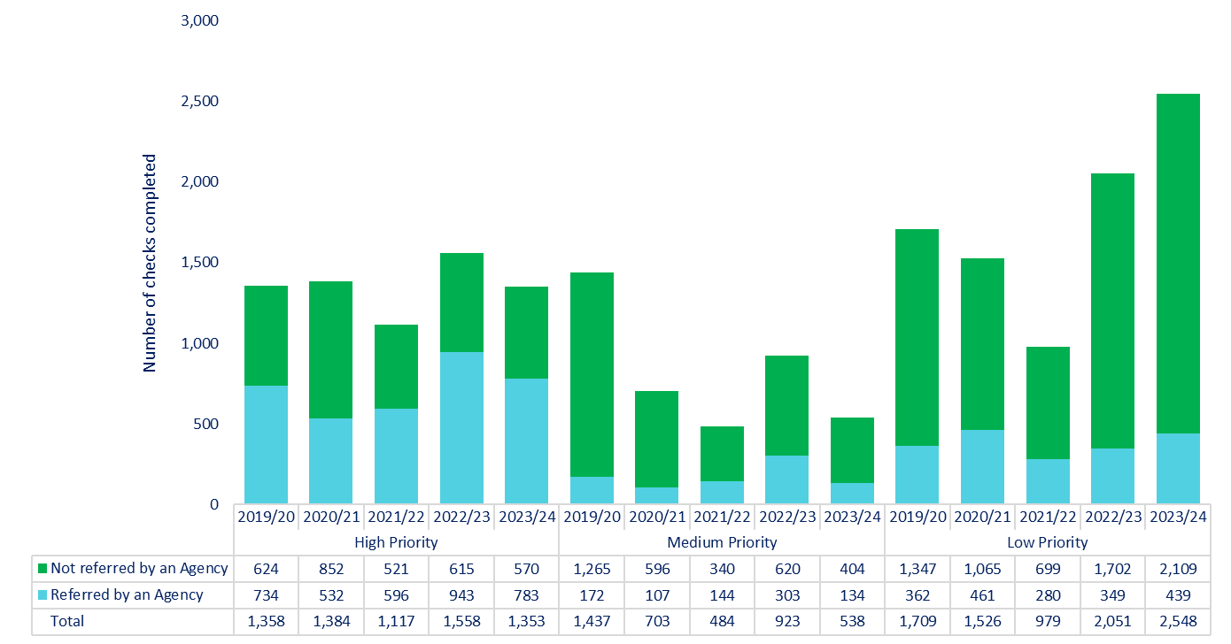

|  |  |  |  |  |  |  |  |  |  |  |
| --- | --- | --- | --- | --- | --- | --- | --- | --- | --- | --- |
| **Category** | **Year** | **Q1** | **Q2** | **Q3** | **Q4** | **Year- to-Date**  **(YTD)** | **% change YTD** |  | **Average of 3 previous years** | **% Change YTD / Average of 3 previous years** |
|  | | | | | | | |  |  | |
| % of all Safe and Well Checks undertaken that originated from a referral from a partner organisation | **2023-24** | **30.5%** |  |  |  | **30.5%** | ⬇  13.4% |  | 34.6% | ⬇  11.9% |
| 2022-23 | 35.2% |  |  |  | 35.2% |  |
| *The final two columns show: the average of the three previous financial years (based on the equivalent reporting period); the percentage change based on the difference between the current financial year and the three year average. | | | | | | | | | | |

## Actions taken to improve Safe and Well Check performance duirng the previous quarter

* During Q1, a total of 4,439 SAWCs were completed (in line with the target set by the FA of 17,500 for the year), of which 1,353 (30.5%) were high priority. 783 (57.9%) of these came from a partner agency.
* The WT/DC operational Crews SAWC target increased to 15 each tour from Q1.
* Partnership Managers continue to nurture existing, as well as explore new relationships with external partners to identify those persons most vulnerable to fire and provide them with suitable advice and interventions.
* Re-engagement of the previous high priority SAWCs project continued and involves all WT, DC, and WDSR Crews. South, and Mid and West Wales are keen to learn from this initiative.
* Bespoke interventions continued to be provided to the most vulnerable in the community.
* The array of interventions issued to occupiers continued to grow, including innovative equipment such as Stoveguards.
* Attendance at relvent and targeted events to promote the benefits of our work and encourage SAWC referrals continued.

# Planned 18 Pump Availability

1. NWFRS has 44 fire stations with 54 response pumps, as 8 stations have 2 pumps and Wrexham has 3. Pre-planning takes place each day to deploy resources to ensure 18 are made available between 0600 and 1800. Short notice changes can sometimes result in a reduction that cannot be immediately rectified.

During the first quarter of 2023/24, the threshold of 18 was met on all 91 days of quarter one. As this is the first year that the threshold has been lowered to 18 pumps, no comparable data is available.

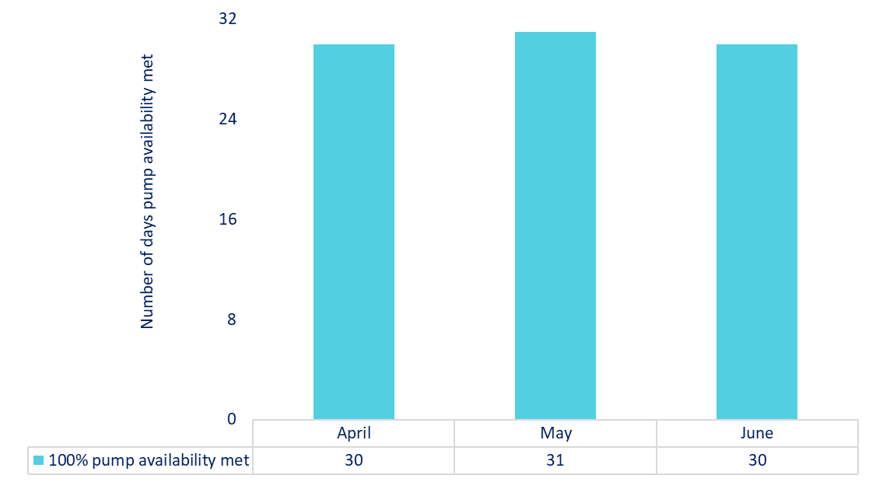

# Sickness Absences

The Service aims to encourage all its employees to maximise their attendance at work while recognising that employees will, from time to time, be unable to come to work because of ill health.

The Office for National Statistics (ONS) reported for 2022, the sickness absence rates were **3.6%** for public sector workers. This is lower than what NWFRS have reported during Q1 of the 2023/24 financial year. During this period a total of **915** individuals were employed by NWFRS. Absences due to sickness during Q1 of the 2023/24 financial year equates to a total of **5.03%**.

However, there are key challenges that all emergency services face in terms of managing attendance and keeping employees in work. These include emotional and physical demands that are unique whereby operational staff may have to remain off work longer due to physically related injuries compared to those in non-operational roles. Also, operational staff need to be physically fit and meet the national fitness standard to enable them to carry out their role safely and effectively.

In comparison with other emergency services and public sector organisations:

* Police (Published 12 January 2022)
  + - The current absence rate for police offices and staff nationally stands at **9.4%**, according to data released by the National Police Chief’s Council (NPCC).
* NHS Wales (Published 23 November 2022)
  + The Welsh Ambulance Services NHS Trust had sickness absence rate of **9.7%** during Q1 of 2022.
  + Betsi Cadwaladr University Health Board’s sickness absence rate was **6.3%** during Q1 2022

Within the quarter, a total of **160** cases of absence were recorded to both long term and short-term sickness combined.

|  |  |  |
| --- | --- | --- |
|  | **Cases** | **Sickness Absence %** |
| **Long Term Sickness** | 60 | 4.26% |
| **Short Term Sickness** | 100 | 0.76% |
| **Total** | **160** | **5.03%** |

# Glossary

|  |  |
| --- | --- |
| Fires | All fires fall into one of three categories – primary, secondary or chimney. |
| Primary Fires | These are fires that are not chimney fires, and which are in any type of building (except if derelict), vehicles, caravans and trailers, outdoor storage, plant and machinery, agricultural and forestry property, and other outdoor structures such as bridges, post boxes, tunnels, etc.  Fires in any location are categorised as primary fires if they involved casualties, rescues or escapes, as are fires in any location that were attended by five or more fire appliances. |
| Secondary Fires | Secondary fires are fires that are neither chimney fires nor primary fires.  Secondary fires do not involve casualties, rescues or escapes, and will have been attended by four or fewer fire appliances.  Secondary fires are those that would normally occur in locations such as open land, in single trees, fences, telegraph poles, refuse and refuse containers (but not paper banks, which would be considered - in the same way as agricultural and forestry property - to be primary fires), outdoor furniture, traffic lights, etc. |
| Chimney Fires | These are fires in occupied buildings where the fire is confined within the chimney structure, even if heat or smoke damage extends beyond the chimney itself.  Chimney fires do not involve casualties, rescues or escapes, and will have been attended by four or fewer fire appliances. |
| Special Service Incidents | These are non-fire incidents which require the attendance of an appliance or officer and include:   1. Local emergencies e.g., flooding, road traffic incidents, rescue of persons, 'making safe' etc; 2. Major disasters; 3. Domestic incidents e.g., water leaks, persons locked in or out etc; 4. Prior arrangements to attend incidents, which may include some provision of advice and inspections. |
| False Alarm (general guidance) | Where the FRS attends a location believing there to be an incident, but on arrival discovers that no such incident exists, or existed.  Note: if the appliance is ‘turned around’ by Control before arriving at the incident it is not classed as having been attended and does not need to be reported. |
| False Alarms - Malicious | These are calls made with the intention of getting the FRS to attend a non-existent incident, including deliberate and suspected malicious intentions. |
| False Alarms – Good Intent | These are calls made in good faith in the belief that the FRS really would attend a fire or special service incident. |
| False Alarms - AFA | These are calls initiated by fire alarm and fire-fighting equipment. They include accidental initiation of alarm apparatus or where an alarm operates and a person then routinely calls the FRS as part of a standing arrangement, i.e., with no ‘judgement’ involved, for example from a security call centre or a nominated person in an organisation. |
| Building - Dwellings | A property that is a place of residence, i.e., occupied by households, excluding hotels, hostel and residential non-permanent structures. |
| Building - Non-Residential | Properties such as hospitals, offices, shops, factories, warehouses, restaurants, cinemas, public buildings, religious buildings, agricultural buildings, railway stations, sheds, prisons. |
| Building - Other Residential | Properties such as hotels, hotels and residential institutions B&Bs, Nursing/care homes, student halls of residence. |
| Vehicle (Road and Other Transport) | Road vehicle, rail vehicle, aircraft, boat. |
| Outdoor | Fields, grassland, woodland, refuse containers, post boxes. |
| Wildfires | A grassland, woodland and crop fire where the incident was attended by 4 or more vehicles, or the Service was in attendance for 6 hours or more, or where there was an estimated fire damage area of over 10,000 square meters. |
| Short Term Sickness (STS) | Absences 27 calendar days and under. |
| Long Term Sickness (LTS) | Absences 28 calendar days and over. |